INTERVIEW CAPM NOTES
What is BTP and Cloud Foundry >
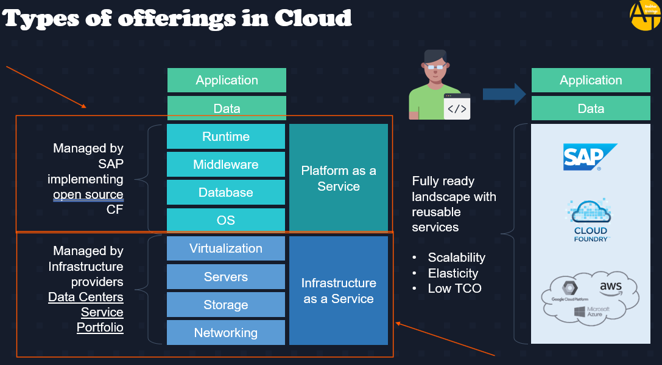
Basically on-Prem means we have to handle everything on our own that mentioned on above screenshot, and in case of cloud we get 3 options – IAAS, PAAS and SAAS. BTP is a PAAS basically SAP partnered with Amazon AWS, Azure cloud provider and form the IAAS and for PAAS SAP took open-source code of Cloud Foundry and did changes on top of it like adding Hana, ABAP runtime and others and made the whole thing as SAP cloud platform Known as BTP, where we can made application and deploy on it.
Cloud Foundry – It’s a Platform as a Service and also, it’s an open source, provided by Pivotal. Remember SAP has included HANA DB, ABAP etc. on top of Cloud Foundry platform and make a Cloud Platform called BTP.
>> SELF HEALING MECH In BTP each application that we deploy executes in a self-healing mechanism called cell, in cell we have containers (application + runtime) which runs the application, if any container got stop then in cell, we have cell wrap which call CF engine and CF engine create another cell and garden and container and runs another instance of that application.
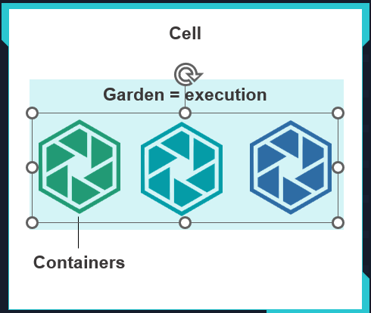
BTP ORG Structure > Very IMP
BTP has global account at start like for example IBM is an organization and it will have Global account while purchasing BTP services (Global account used for the purpose of Billing for a Customer), but for its various subsidiaries say in US it has one, where they are doing all Finance related works, another in India where doing HR related and in Canada where doing Operations related. Then this subsidiaries or department will have Sub-account which will consist of data center according to location. Then say if US IBM subsidiary has 2 Parts in same place, one is Finance another one working in Sales then this will be handled by Dictionary (it’s a group of Sub-accounts). Space Quata is nothing but Dev, Test and Prod environment separations within the subaccount.
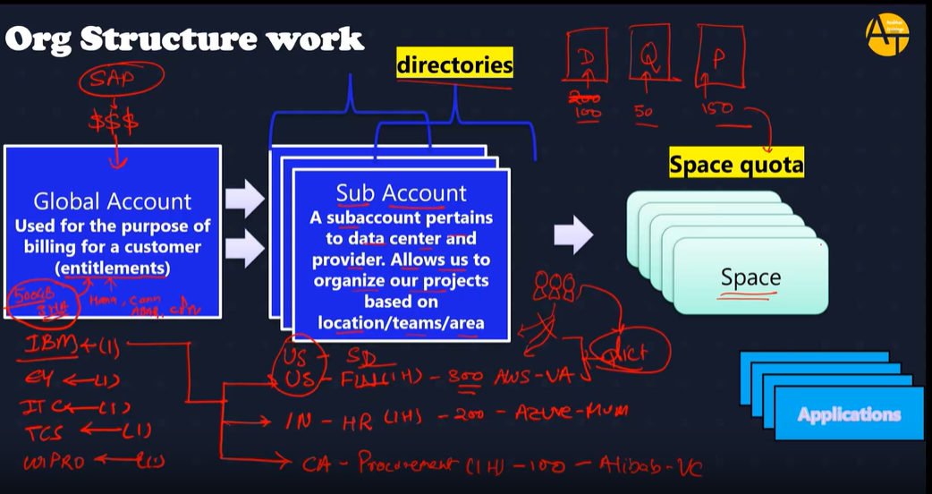
Entitlement >
Entitlements are the heart of all subaccounts in SAP BTP. They define which service and runtime artifacts you are able to use. When you purchase an enterprise account, you’re entitled to use a specific set of resources, such as the amount of memory that can be allocated to your applications.
An entitlement is your right to provision and consume a resource. In other words, entitlements are the service plans that you're entitled to use.
Quota >
A quota represents the numeric quantity that defines the maximum allowed consumption of a resource. In other words, how much of a service plan you're entitled to use.
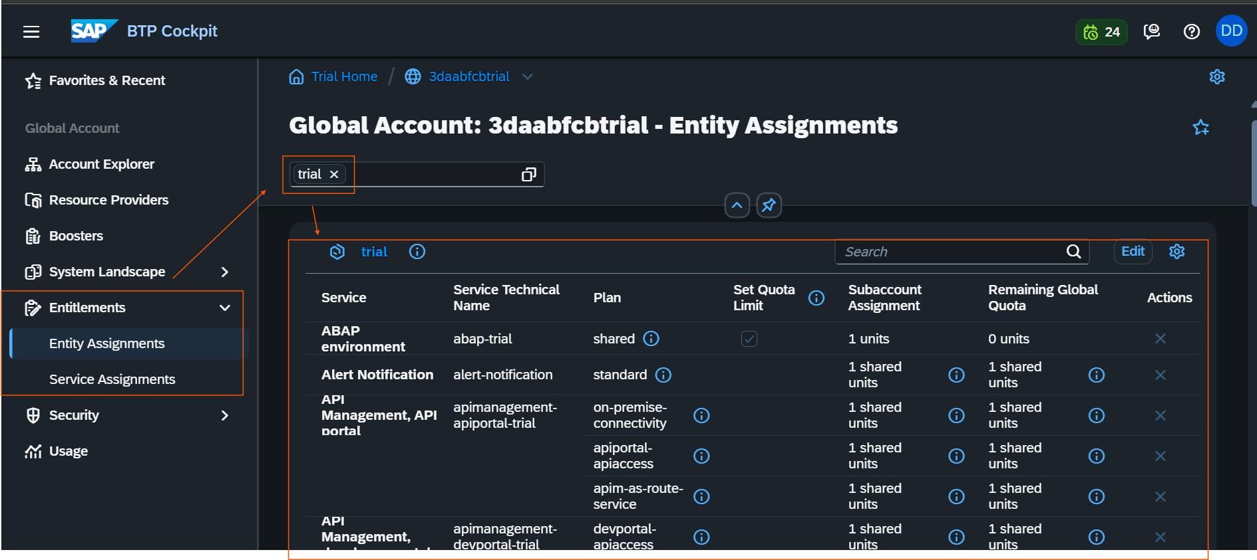
Above screenshot shows how entitlements are assigned to subaccount level (During global account purchase we get Entitlements like Hana, Cloud Foundry and other services of BTP that we can use with amount of memory (quota)) we further subdivide all the Entitlements to Subaccount level with quota value.
Spaces >
Spaces are like Dev, Quality and prod that you have created under our Sub-account basically where we can manage deployed apps. To restrict memory for spaces we have to create Quota plans.
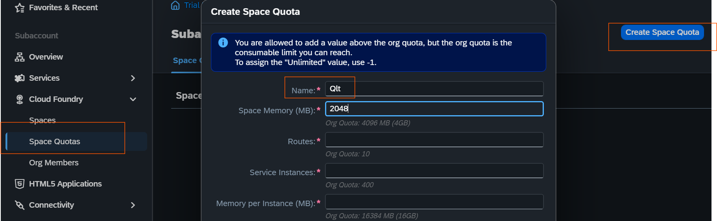
Above example shows how we can distribute memory in spaces by creating quota plan.
Environment, Subscription and Instance (Backing Services) –
Environment is nothing but the actual platform-as-a-service offering of SAP BTP that allows for the development and administration of business applications.
SAP BTP offers three environments: ABAP, Cloud Foundry and Kyma.
Subs and Instance are service provided by SAP BTP, Subs are like URL which we can use for example SAP BAS, we first have to subscribe, instance are the purest services, is nothing but the connection, auth, databases. Which we can use while building our application. Instance Service Requires Service Key after installing instances. Service Key will have all the passwords, information to talk to instance.
How to check service plan of SAP BTP Entitlements >
Navigate to SAP Discovery Center - https://discovery-center.cloud.sap/
Steps to deploy any application in CF from VS Code >
- Open project in VS Code, Open corresponding Terminal.
- Type cf login -a “your api end point from btp” >> https://api.cf.us10-001.hana.ondemand.com/
- Then enter email and Password.
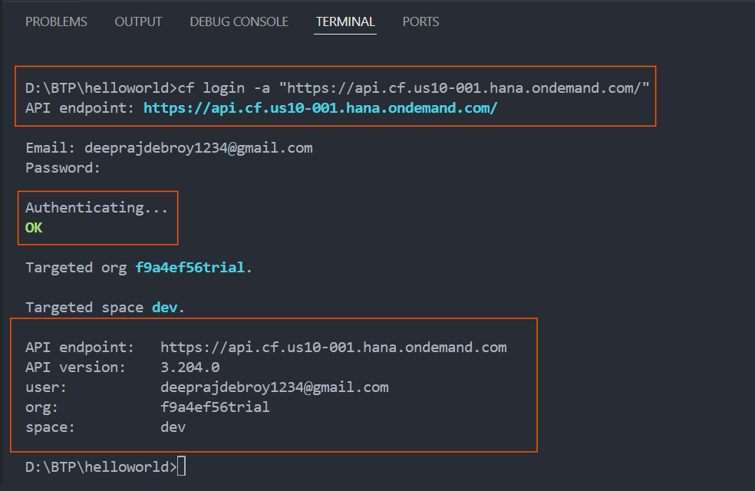
- We can check all the available runtime name in BTP CF using cf buildpacks
- Cf push – is used to deploy project to cloud foundry (here we are deploying go project)
- CF login
- CF apps – for all apps
- CF scale APPNAME -m 2048M (can be used for both up and downscale)
- CF scale APPNAME -i 2
Above from 6 to number 9 is for scaling of apps when deployed to Cloud foundry, The increase in number of instances is horizontal scaling and increase in memory of instance is Vertical scaling.
CAPM >
CDS >
Basically, we use CDS in CAPM because it helps mostly on changing DB, as if we use SQL and have MySQL Db then if we certainly want to migrate to HANA then need to change whole SQL code as syntax is different.
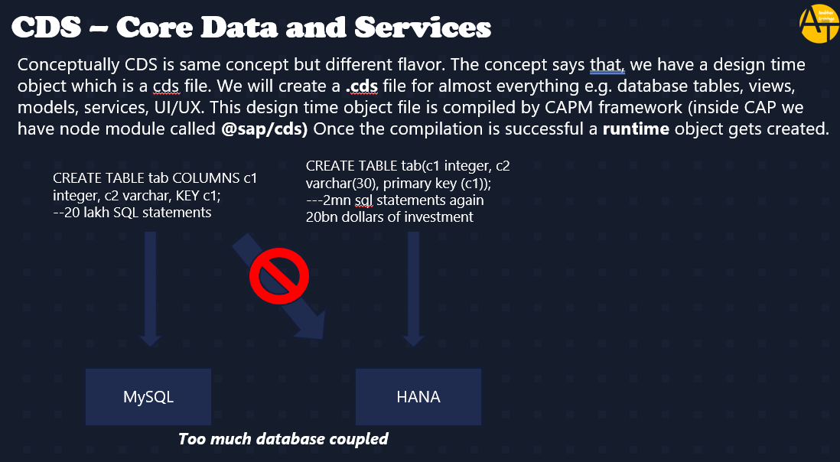
Solution -
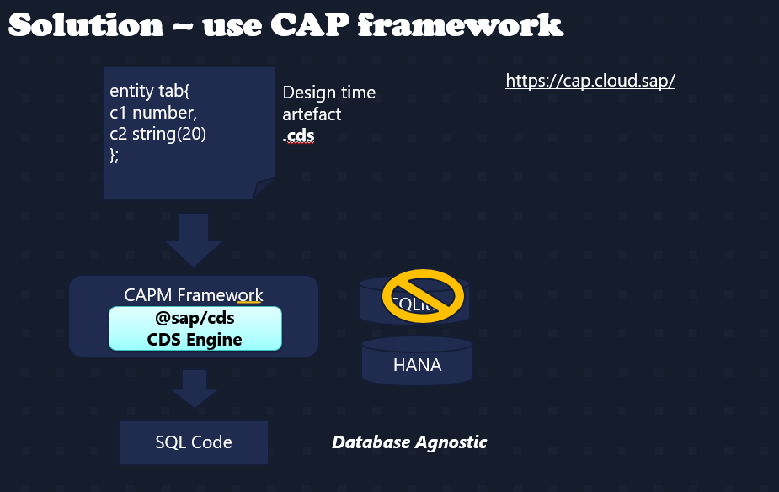
Basically, CAP framework @sap/cds helps to convert to the DB specific code.
Basic CAPM Project structure >
For creating basic CAPM project structure follow below –
- Create a Project Folder
- Go for CDS init for creating CDS project structure
- Npm install for installing all the dependency from package.json file.

